Prove: ∀n≥1: Fn = an + 1

Given: Fibn = Fibn-1 + Fibn-2, n>2

Fibn = 1, n≤2

an = an-1 + an-2 + 1 (the recurrence relation)

1. Induction base

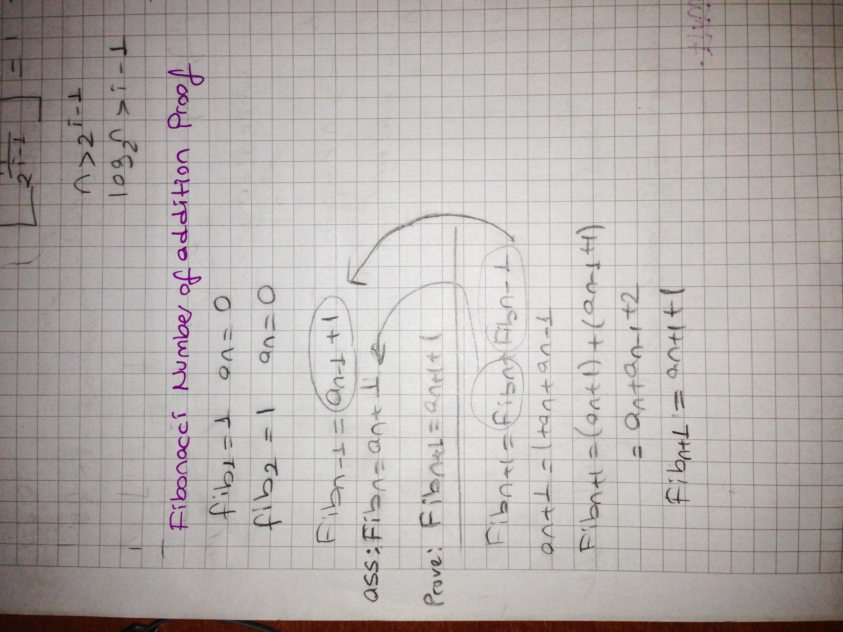

= (an + 1) + (an-1 + 1) = an + an-1 + 2

Assume:

2. Induction step

But from recurrence relation an+1 = an + an-1 + 1

Therefore, Fibn+1 = an+1 + 1

3. Proved for ∀n.